**Name: Kate Amarachukwu Igwilo**

**Admission ID: CG/24/0135**

**Project ID: 001**

**An in-depth comparison of the OSI and TCP/IP models. Analyze the strengths and weaknesses of each layer and how they handle specific functionalities like error correction, routing, and flow control.**

**INTRODUCTION**

Computer networks are collections of separate computers connected by a common protocol. The bit-by-bit aspect of computer-to-computer communication is described in these protocols. Network protocols set forth the guidelines for how data should be formatted and conveyed in messages, as well as how devices should locate and establish connections with one another (Annu and Anil, 2024). The TCP/IP and OSI are network reference models. Early in the 1970s, both models were developed. While packet delivery and network interface error recovery are handled by the TCP/IP models, error detection is handled by the OSI model. Since fewer layers are preferred and using various protocols to manage data transmission is detrimental to the survival of the original OSI model, all modern networking equipment implements the TCP/IP model (Ezeagwu *et al.*, 2021).

**1.1 OSI (Open Systems Interconnection) Model**

It is a conceptual framework that standardizes the functions of a telecommunication or computing system into seven distinct layers (Afroz, 2022). OSI functions as a thorough, protocol-neutral framework intended to cover a range of network communication techniques. They include;

1. Physical Layer: Transmits raw data bits over a communication channel.

2. Data Link Layer: Handles framing, error detection, and flow control.

3. Network Layer: Focuses on routing and logical addressing.

4. Transport Layer: Provides end-to-end error correction, flow control, and data integrity.

5. Session Layer: Manages sessions between applications.

6. Presentation Layer: Translates data between application and network formats.

7. Application Layer: Supports end-user applications (Annu and Anil, 2024).

**1.1.1 Strengths of OSI**

a) Modular design: The distinct division of duties makes it easier to comprehend, apply, and troubleshoot.   
b) Promotes interoperability: By standardizing the functionality of each layer, equipment from various vendors can interact with one another.   
c) Extension: New protocols are implemented without interfering with existing layers.

**1.1.2 Weaknesses of OSI**

a) The seven-layer architecture may be unduly complex, which makes practical implementation difficult.   
b) Redundancy: Inefficiencies from certain functionalities being replicated across levels.   
c) They can only be used as reference models and cannot operate in parallel because each layer must wait to receive data from the layer before it (Annu and Anil, 2024).

**1.2 TCP/IP (Transmission Control Protocol/Internet Protocol) model**

The TCP/IP is a more straightforward, four-layer conceptual and practical model that tackles certain communication issues. It was created by DARPA to define how a networking system operates and to explain how the Internet operates (Afroz, 2022). The layers are:

1. Link Layer: Equivalent to the combination of OSI's Physical and Data Link layers.

2. Internet Layer: Corresponds to the OSI Network Layer, focusing on IP addressing and routing.

3. Transport Layer: Combines functionalities of the OSI Transport Layer, providing error correction, flow control, and data integrity.

4. Application Layer: Corresponds to the top three layers of the OSI model, handling end-user applications (Fortinet, 2024).

**1.2.1 Strengths of TCP/IP**

a) TCP/IP assists you in figuring out how to connect machines to the internet and how to send data back and forth between them.   
b) It facilitates the creation of a virtual network.   
c) Easy to understand and effective: TCP/IP specifies how data should be addressed, sent, packetized, routed, and finally received. It is all about end-to-end data transmission.   
d) TCP/IP is very scalable

**1.2.2 Weaknesses of TCP/IP**

a) TCP/IP has fewer tightly defined layers, which may cause misunderstandings and inconsistent behavior.   
b) Limited extensibility: It could be necessary to make changes at several levels to add new functionalities or protocols.   
c) Less modular: Because TCP/IP's design does not strictly enforce the separation of concerns, interoperability and troubleshooting problems may arise.

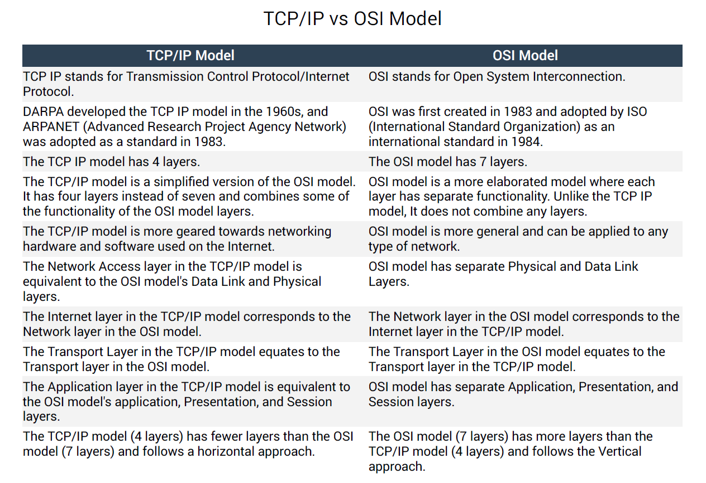

Figure 1: Comparison summary of OSI and TCP/IP models (Afroz, 2022).

**1.3 Error Correction, Routing, and Flow Control**

The Transport Layer is where error correction is mostly addressed in both models. This is the job of Layer 4 (Transport Layer) in OSI, and Layer 3 (Transport Layer) in TCP/IP is likewise in charge of it. TCP uses methods like acknowledge and retransmission to deliver dependable, connection-oriented error correction.   
The Network Layer (Layer 3), which implements logical addressing and routing protocols, is responsible for routing under the OSI model. IP addressing and routing protocols like IP and ICMP are used at the Internet Layer (Layer 2) of TCP/IP, where routing is also carried out.   
The Transport Layer is where both models mainly manage flow control. While TCP/IP's Transport Layer (Layer 3) also implements flow control using protocols like TCP's sliding window mechanism, OSI's Transport Layer (Layer 4) handles flow control through methods like windowing (Rajendra and Dhanda, 2017).

**1.4 CONCLUSION**

The intricacy, layering, and adoption of the two models vary, but they both offer a framework for comprehending and putting network communication into practice. Although TCP/IP was developed by the Department of Defence (DoD) to ensure the security of classified military information and open communication during emergencies, OSI is a communication structure that illustrates how information packages travel across a network.

**REFERENCE**

Afroz Ahmad. (2022). *TCP/IP vs OSI Model: Differences and Similarities*. *Afroz Ahmad's Blog*. *Retrieved on 22nd April* from <https://afrozahmad.com/blog/tcp-ip-vs-osi-model-differences-and-similarities/>

Annu, L. and Anil, D. (2024). Review of the OSI Model and TCP/IP Protocol Suite on Modern Network Communication. *International Journal of Current Science Research and Review*, 7(2).

Ezeagwu, C.O., Kelvin, N. N., Cyprian, O. and Ekene, E. A. (2021). Comparative Analysis of OSI and TCP/IP Models in Network Communication. *Journal of Software Engineering and Simulation,* 7(6):08-14

Fortinet. (2024). *TCP/IP Model vs. OSI Model. Fortinet Cyber Glossary*. *Retrieved on 22nd April* <https://www.fortinet.com/resources/cyberglossary/tcp-ip-model-vs-osi-model>

Rajendra K. and Namrata, D. (2017). An Evaluation of OSI Reference Model and Comparison with TCP/IP Model. *International Journal of Engineering and Techniques*, 3(4):26-28